Week Ending: |  |  | DAY: |  |  | Subject: Mathematics
Duration: 60mins per lesson |  |  |  |  |  | Strand: Number
Class: B1 |  |  | Class Size: |  |  | Sub Strand: Counting Representation And Cardinality
Content Standard:  B1.1.1.1: Describe numbers and the relationship between numbers 0 to 100 |  |  | Indicator:  B1.1.1.1.1: Use number names, counting sequences and how to count to find out “how many?” |  |  |  |  | Lesson:  1 OF 1
Performance Indicator:  Learners can read and write number names from (1-9) |  |  |  |  | Core Competencies:  Problem Solving skills; Critical Thinking; Justification of Ideas;
Teaching/ Learning Resources |  | Counters patterns made from manila cards
New words |  | Number names, one, two, three, four, five, six, seven, eight, nine
References: Mathematics Curriculum Pg.
DAYS | PHASE 1: STARTER |  |  | PHASE 2: MAIN |  |  | PHASE 3: REFLECTION
Monday  Tuesday | Engage learners to sing songs in relation to the lesson.  Example “A circle is a shape”  Write these numbers on the board and deduce from learners if they can mention any of the names there. Expected answers one, five, nine, etc.  Engage learners to sing songs in relation to the lesson.  Example ““I’m counting one”  Write these numbers on the board and deduce from learners if they can mention any of the names there. Expected answers one, five, nine, etc. |  |  | Number names (1-5)  Have learners count forwards and backwards (1-9).  Put them into groups of 5. Give them numeral cards (1-5) and number name cards (one-five) to each group. Arbitrarily they pick objects from one to five, pick a numeral card and a number name card to match the objects  Show a pictures of dice and have learners count the dice there up to 5, pick a numeral card and a number name card to match them one by one.  Give them numeral cards 1-3. They make groups of objects (1-3) pick a numeral card and number name cards and match them to the groups of objects made. They should work in pairs  Assessment  In groups of 5, learners work with bottle caps and number name cards. They make groups of objects (1-5) arbitrarily and match the number names cards to the groups made. Let them also write the number names up to “five”.  Number names (6-10)  Working in pairs, learners pick objects to represent a number (6-9) that you have called out. They pick a numeral card and a number name card to match the group of objects.  Display objects on the teachers table. Call learners to count the number of objects and read the number names.  Have learners make groups of objects up to 7 and match numeral cards and number name cards to the groups made.  Assessment  Working in pairs, learners make groups of objects up to 10, and match numeral and number name cards to the groups made |  |  | Summarize with learners the important points in the lesson.  Homework  Write number names for these numerals.  5 ______  2 ______  3 ______  1 ______  4 ______  Summarize with learners the important points in the lesson.  Homework  Write number names for these numerals:  (1) 9  (2) 6  (3) 8  (4) 7  (5) 10
Wednesday | Engage learners to sing songs in relation to the lesson.  Example ““I’m counting one”  Make two groups of toffees.  Learners tell you the number of toffees in A and B? There are no toffees in B or there is nothing in B. |  |  | The number zero (0)  Call five learners to the front of the class. Give 3 straws to one and ask him/her to hand them out to the 4 learners. One learner will get “nothing”.  Line up four bowls in front of the class. Put 3, 2, and 1 objects respectively in them. Elicit from learners the number of objects in the fourth one. “Nothing”. Now introduce the symbol for nothing as 0 (zero).  Ask learners, if you have 2 heads, stand up. No one is expected to stand up. This means that there are no learners with 2 heads. So, the number of learners with 2 heads is zero.  Referring to the learners’ book, instruct learners to look at the pictures and tell you the number of apples in each bowl.  There are no apples (nothing) in bowl C.  Let learners know that nothing means zero and how it is written.  Have learners write the symbol 0 (zero) in their jotters.  Have learners draw empty containers to represent the idea of nothing in the box. |  |  | Summarize with learners the important points in the lesson.  Homework  Write the numerals for these groups of objects.  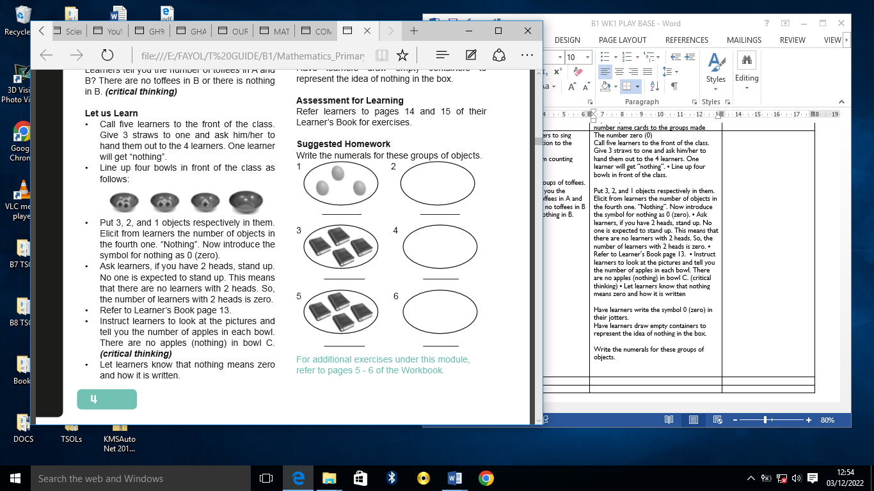
Thursday | Play ‘‘fingers up and down’’ Hold up a number of fingers. Learners say the number name. They also say the number of fingers that are down.  Show some pictures in the learner’s book and ask them what they can see in the pictures and let them talk about it. |  |  | Counting forwards by 1s (1-20)  Call about 20 learners to line up in front of the class. Give each learner a numeral card (1-20). They sing a song.  Let each learner mention the numeral card that he/she is holding.  1 2 3 4 5 6 7 8  9 10 11 12 13 14 15 16  17 18 19 20  Let them count forwards from 1 to 20. Put learners into groups of 5. Let each group select a leader.  Give each group a number chart. Ask learners in turns to read the numbers aloud.  Tell them to start on any number, e.g. 1, 5, etc. They can start on 20 and count up to 40.  Assessment  Present learners with numeral cards 1 to 20. Call out learners to count forwards from 1 to 20. Each learner can start on any number. They should work in pairs.  Put before them a 1-50 number chart. Have learners count forwards from any number |  |  | Summarize with learners the important points in the lesson.  Homework  Count forwards to complete the number lines  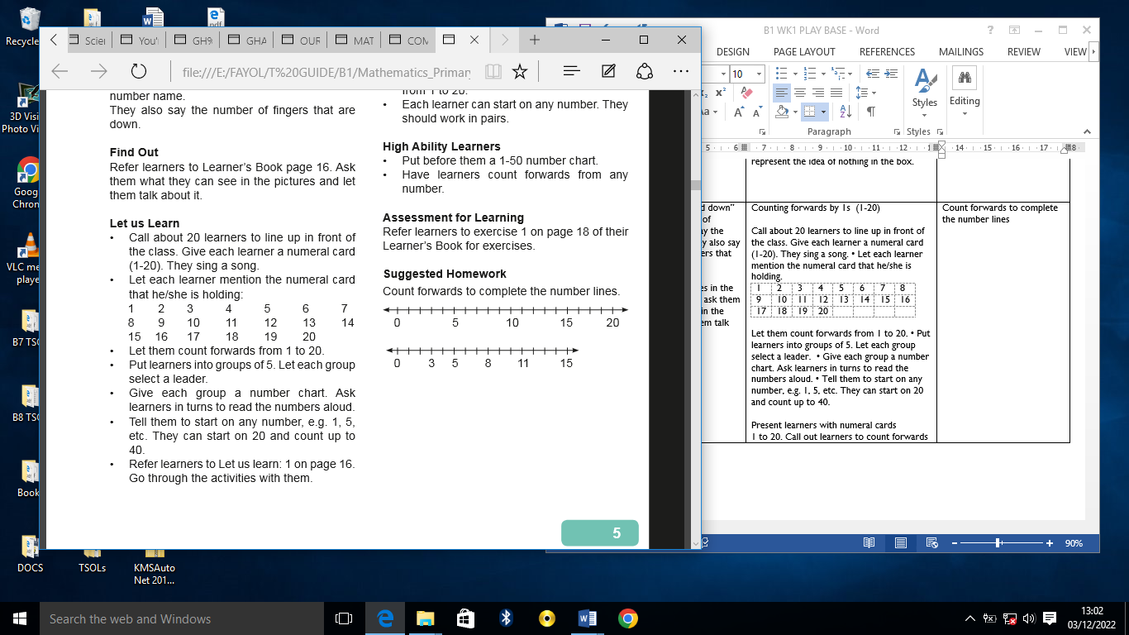
Friday | Clap a number of times (between 1 and 20) and let learners tell you the number |  |  | Counting backwards by 1s (20-1)  Call about 20 learners to line up in front of the class. Give each learner a numeral card (1-20).  Let each learner mention the numeral card that he/she is holding.  1 2 3 4 5 6 7 8  9 10 11 12 13 14 15 16  17 18 19 20  Let them count backwards from 20 to 1.  Put learners into groups of 5. Let each group select a leader.  Give each group a number chart. Ask learners in turns to read the numbers aloud. Tell them to start on 20 and count backwards.  In turns, they can start on different numbers but they should count backwards from the selected number.  Put before them a 1-50 number chart. Have learners count backwards from any number. Allow it if they start from numbers bigger than 50. |  |  | Summarize with learners the important points in the lesson.  Homework  Count backwards to complete the number line.  